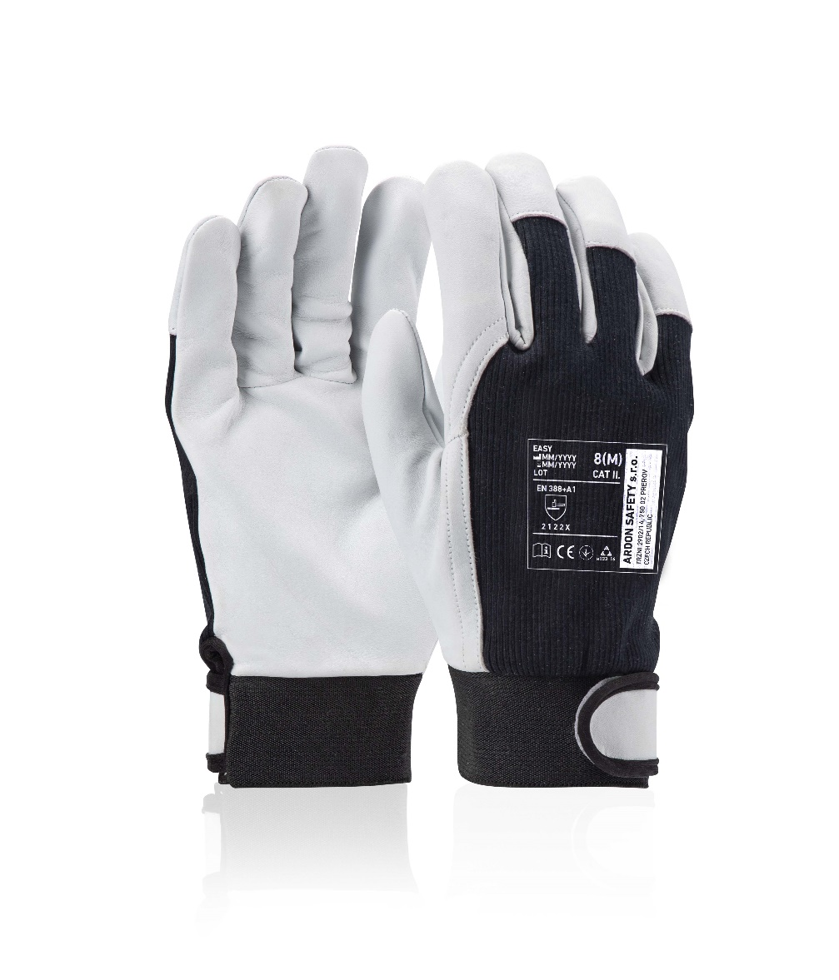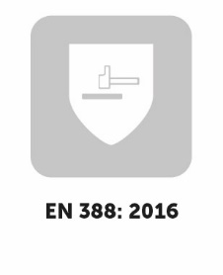

HANDLING IN DRY ENVIRONMENT

**EASY**

**TECHNICAL DATA**

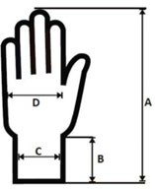

**SIZE(S)**

**UNIT**

**PACKING**

Units in carton

Units in polybag

Retail packaging

HANDLING IN DRY ENVIRONMENT

120 pairs

12 pairs

N/A

sheep skin leather (white)

cotton (black)

rubber + Velcro

0,8 – 1,0 mm (in palm)

7 / S – 11 / 2XL

pair

**TECHNICAL DATA**

**EASY**

|  |  |  |  |  |  |  |  |  |
| --- | --- | --- | --- | --- | --- | --- | --- | --- |
| **DIMENSIONS** | **5** | **6** | **7** | **8** | **9** | **10** | **11** | **12** |
| Carton H x W x D (cm) | - | - | 54x26x30 | 54x26x30 | 54x29x30 | 59x28x30 | 59x28x30 | - |
| Carton (cbm) | - | - | 0,0421 | 0,0421 | 0,0470 | 0,0496 | 0,0496 | - |

|  |  |  |  |  |  |  |  |  |
| --- | --- | --- | --- | --- | --- | --- | --- | --- |
| **WEIGHT** | **5** | **6** | **7** | **8** | **9** | **10** | **11** | **12** |
| Carton (kg) | - | - | 9,50 | 9,80 | 10,2 | 10,5 | 11,4 | - |
| Unit (g) | - | - | 71,0 | 74,0 | 77,0 | 80,0 | 87,0 | - |

**DESCRIPTION**

Combined gloves made of sheep skin leather with cotton back and velcro cuff.

|  |  |  |  |  |  |  |  |  |
| --- | --- | --- | --- | --- | --- | --- | --- | --- |
| **Size chart (cm)** | **5** | **6** | **7** | **8** | **9** | **10** | **11** | **12** |
| Total length (A) | - | - | 22,0 | 23,0 | 24,0 | 25,0 | 25,5 | - |
| Cuff length (B) | - | - | 3,80 | 3,80 | 3,80 | 3,80 | 3,80 | - |
| Cuff width (C) | - | - | 8,00 | 9,00 | 9,50 | 10,0 | 10,5 | - |
| Palm width (D) | - | - | 9,00 | 9,50 | 10,0 | 10,5 | 10,8 | - |
|  |  |  |  |  |  |  |  |  |
| Tolerance (A) ± 0,20 (cm) |  |  | Tolerance (C) ± 0,10 (cm) | | | | | |
| Tolerance (B) ± 0,10 (cm) |  |  | Tolerance (D) ± 0,20 (cm) | | | | | |

**MATERIAL**

Palm

Back

Cuff

Thickness

**A1083**

**CODE**

# **STANDARDS**

# **(EU) 2016/425**

**EN ISO 21420:2020** Protective gloves – general requirements and test methods

**EN 388:2016 + A1:2018** Protective gloves against mechanical risks

|  |  |  |  |
| --- | --- | --- | --- |
| PROTECTION LEVELS | | | |
| **MECHANICAL RISKS** | **LVL** | **score** | **unit** |
| abrasion resistance | 2 | 500 – 2.000 | cycles |
| cut resistance | 1 | 1,2 – 2,5 | index |
| tearing resistance | 2 | 25 – 50 | N |
| puncture resistance | 2 | 60 – 100 | N |
| cut resistance acc. to ISO | X | not measured | N |

**SPECIAL FEATURES**

- equipped with a velcro cuff thanks to which they do not slip out of the hand or move



**TECHNICAL DATA**

|  |  |  |
| --- | --- | --- |
| **Basic packaging (without sales label)** | **EAN** |  |
| A1083/07 | 8592390115522 |  |
| A1083/08 | 8592390115539 |  |
| A1083/09 | 8592390115546 |  |
| A1083/10 | 8592390115553 |  |
| A1083/11 | 8592390115560 |  |
|  |  |  |

**TECHNICAL DATA**