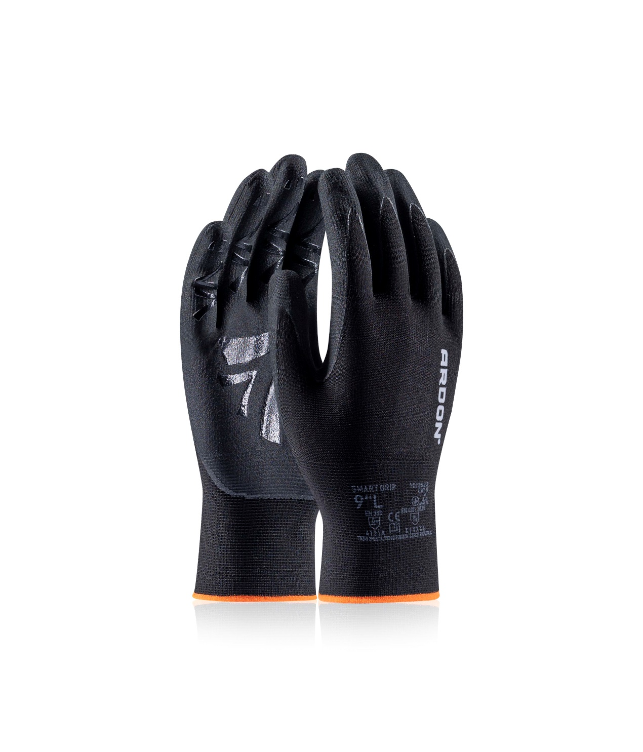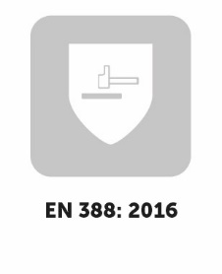

**ARDON®Smart Grip**

ACCURATE HANDLING IN DRY ENVIRONMENT WITH EXTRA GRIP

**TECHNICAL DATA**

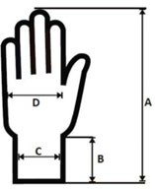

ACCURATE HANDLING IN DRY ENVIRONMENT WITH EXTRA GRIP

**SIZE(S)**

**UNIT**

**PACKING**

Units in carton

Units in polybag

Retail packaging

120 pairs

12 pairs

sales label

**TECHNICAL DATA**

**ARDON®Smart Grip**

|  |  |  |  |  |  |  |  |  |
| --- | --- | --- | --- | --- | --- | --- | --- | --- |
| **DIMENSIONS** | **5** | **6** | **7** | **8** | **9** | **10** | **11** | **12** |
| Carton H x W x D (cm) | - | - | 46x25x26 | 46x26x30 | 46x26x30 | 46x28x32 | 46x28x32 | - |
| Carton (cbm) | - | - | 0,0300 | 0,0359 | 0,0359 | 0,0412 | 0,0412 | - |

|  |  |  |  |  |  |  |  |  |
| --- | --- | --- | --- | --- | --- | --- | --- | --- |
| **WEIGHT** | **5** | **6** | **7** | **8** | **9** | **10** | **11** | **12** |
| Carton (kg) | - | - | 5,50 | 5,90 | 6,50 | 6,90 | 7,40 | - |
| Unit (g) | - | - | 35,0 | 38,0 | 43,0 | 46,0 | 50,0 | - |

**DESCRIPTION**

Fine nylon knit dipped in durable nitrile microfoam with anti-slip finish.

|  |  |  |  |  |  |  |  |  |
| --- | --- | --- | --- | --- | --- | --- | --- | --- |
| **Size chart (cm)** | **5** | **6** | **7** | **8** | **9** | **10** | **11** | **12** |
| total length (A) | - | - | 22,0 | 23,0 | 24,0 | 25,0 | 26,0 | - |
| cuff length (B) | - | - | 7,20 | 7,40 | 7,60 | 7,80 | 8,00 | - |
| cuff width (C) | - | - | 7,40 | 7,60 | 7,80 | 8,00 | 8,20 | - |
| palm width (D) | - | - | 9,00 | 9,50 | 10,6 | 11,1 | 11,6 | - |
|  |  |  |  |  |  |  |  |  |
| Tolerance (A) ± 1,00 (cm) |  |  | Tolerance (C) ± 0,70 (cm) | | | | | |
| Tolerance (B) ± 0,70 (cm) |  |  | Tolerance (D) ± 0,70 (cm) | | | | | |

15G nylon, lycra (black)

nitrile microfoam (black) with antislip “A“ patterned finish

±1,1 mm (in palm)

7 / S – 11 / 2XL

pair

**MATERIAL**

Lining

Coating

Thickness

**A8024**

**CODE**

# **STANDARDS**

# **(EU) 2016/425**

**EN ISO 21420:2020** Protective gloves – general requirements and test methods

**EN 388:2016 + A1:2018** Protective gloves against mechanical risks

|  |  |  |  |
| --- | --- | --- | --- |
| PROTECTION LEVELS | | | |
| **MECHANICAL RISKS** | **LVL** | **score** | **unit** |
| abrasion resistance | 4 | > 8.000 | cycles |
| cut resistance | 1 | 1,2 – 2,5 | index |
| tearing resistance | 3 | 50 – 75 | N |
| puncture resistance | 1 | 20 – 60 | N |
| cut resistance acc. to ISO | A | 2 – 5 | N |

**EN 407:2020** Protective gloves against heat or flame

|  |  |  |  |
| --- | --- | --- | --- |
| PROTECTION LEVELS | | | |
| **THERMAL RISKS** | **LVL** | **score** |  | |
| resistance to burning | X | not measured |  | |
| resistance to contact heat | 1 | 100°C for 15s |  | |
| resistance to convectional heat | X | not measured |  | |
| resistance to radiant heat | X | not measured |  | |
| resistance to small drops of molten metals | X | not measured |  | |
| resistance to large drops of molten metals | X | not measured |  | |

**SPECIAL FEATURES**

- “A“ shaped nitrile antislip coating on palm and fingers for safer and softer grip

- fine 15 gauge liner

- hem free finish

- every size with different hem colour

- ARDON® design:

▪ reflective manufacturer's logo

▪ each pair retail ready

- clean industrial look

**TECHNICAL DATA**

|  |  |  |
| --- | --- | --- |
|  | **EAN** | **HEM COLOR** |
| **Retail packaging (with sales label)** |  |  |
| A8024/07-SPE | 8592390180803 | yellow |
| A8024/08-SPE | 8592390180810 | green |
| A8024/09-SPE | 8592390180827 | orange |
| A8024/10-SPE | 8592390180834 | blue |
| A8024/11-SPE | 8592390180841 | red |
|  |  |  |

**TECHNICAL DATA**

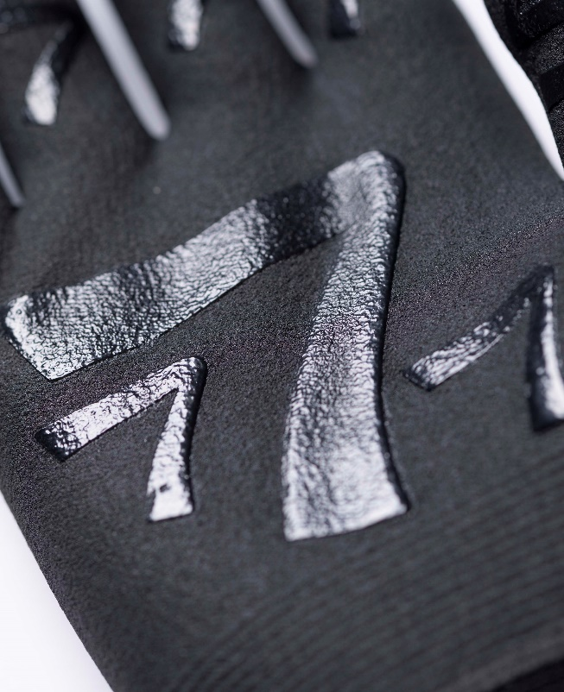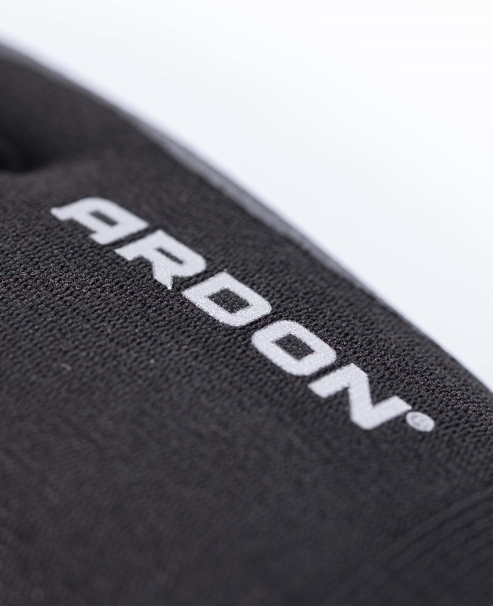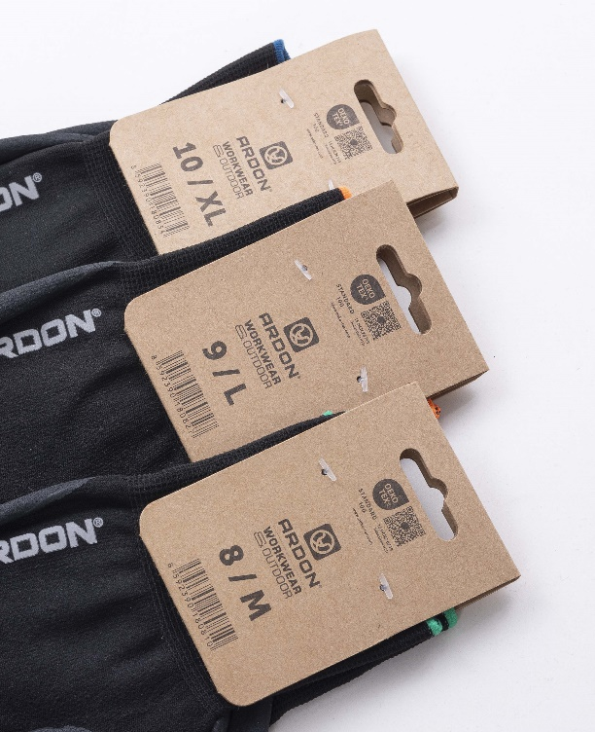

**TECHNICAL DATA**